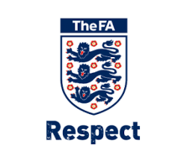

PLAYER CODE OF CONDUCT

We all have a responsibility to promote high standards of behaviour in the game.
As a player, you have a big part to play. That is why Robin Hood Athletic JFC and The FA are asking every player to follow a Respect Code of Conduct.

When playing football, I will:
• Always play to the best of my ability
• Play fairly – I will not cheat, complain, or waste time
• Respect my team-mates, the other team, the referee, or my coach/manager
• Play by the rules, as directed by the referee
• Shake hands / Fist Pump with the other team and referee at the end of the game
• Listen and respond to what my coach / team manager tells me
• Talk to someone I trust or the club welfare officer if I am unhappy about anything at
my club.

I understand that if I do not follow the Code, any or all of the following actions may be taken by Robin Hood Athletic JFC, County FA or The FA I may:
• Be required to apologise to my team-mates, the other team, the referee or team manager
• Receive a formal warning from the coach or the club committee
• Be dropped or substituted
• Be suspended from training
• Be required to leave the club.
• My club, County FA or The FA may make my parent or carer aware of any infringements of the Code of Conduct
• The FA / County FA could impose a fine and suspension against my club
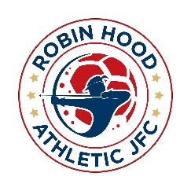
PARENTS CODE OF CONDUCT
We all have a responsibility to promote high standards of behaviour in the game.
As a parent, you have a big part to play. That is why Robin Hood Athletic JFC and The FA are asking every parent and supporter to follow a Respect Code of Conduct.

- Have fun, it is what we are all here for!
- Celebrate effort & good play from both sides.
- Always respect the referee and coaches and encourage players to do the same.
- Stay behind the respect barrier and never enter the field of play.
- When player’s make mistakes, offer them encouragement to try again next time.
- Never engage in, tolerate offensive language, insulting or abusive language or behaviour.

I UNDERSTAND THAT IF I DON’T FOLLOW THE CODE, I MAY BE:

- Issued with a verbal warning or asked to leave the venue.
- Required to meet the Club Committee, League or CFA Welfare Officer.
- Obliged to undertake an FA Education Course
- Requested not to attend future games, be suspended or membership removed.
- Required to leave the club with any dependants and/or issued a fine.

